# Sprint Review Notes Template

**Group**: TUES-18:30-5

**Sprint:** 3

**Date:** 13/10/20

**Attended:** All members

**Scrum Master:** Caspar Koutsoukis

**Product Owner:** Mohamed Ali

**Scrum team:**

Lachlan Boughton

Tianchen Zhuang

Wuchi Chen

Christopher Wasco

Caspar Koutsoukis

**Client Name:** Mohamed Ali

## 1- What was the goal for this sprint? (Product Owner)

The goal of this sprint was to complete as much of our deliverable was possible, as it was this is the last sprint for the project. Our initial goal was to connect the backend and frontend at the very least with the register and login function. The amount of functionality introduced, especially in the last week was substantial. At the end of the sprint, we managed to complete all the basic functionality for a booking application at the very least, with additional features such as an admin dashboard. This was the goal of the sprint; complete as much functionality as possible.

## 2- Review of the requirement (Product Owner)

The following was implemented by the end of the sprint, all relevant features for a booking application:

* Admin Dashboard – view all businesses and customers
* Deploy to AWS
* Register as a user, register as a business
* Login as a user, login as a business
* Create an event as a business
* Book for an event as a customer
* Delete/Alter a booking as a customer and admin
* Delete/Alter an event as a business
* View all bookings a user has booked
* Delete businesses and customers as an admin

## 3- Sprint status (Scrum Master)

Plan vs Reality

Sprint Statistics:

The sprint immediately had progress from the get go, we didn’t connect the backend/frontend last sprint, so we had a lot of work to do, as a result, we from the

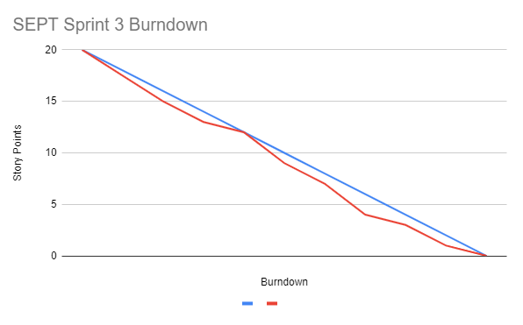

**Estimated Burndown Actual Burndown**

Throughout the entirety of the sprint, we have consistently contributed to the project, to ensure how deliverable is completed on time.

The story points were attributed to the features we implemented, mentioned beforehand. This includes the dashboard, logging in, viewing bookings, etc. If we quantify all that work into 20 story points, we can present this burndown chart as follows; the actual burndown is consistent to the actual workflow throughout the sprint.

## 4- Customer Feedback (Client)

Mohamed’s feedback was very positive, as we presented him our final demo of the deliverable. We demonstrated all the requirements he desired, which includes the basic functionality of a booking system, plus additional features like an admin dashboard.

## 5- Closing (Team)

Our team is extremely satisfied with the work we ended up implementing, especially compared to what we had before the sprint started. As a closing, all team members are very satisfied with our final products features and we have all learnt together the software development process considerably, which will help all of us in our future endeavours in the industry.